**Andrew Wang**

**Homework 2**

1. **Code:**

################

# Author: Andrew Wang

# Date: 9/19/2019

# This program allows the user to input year and the program calculates if there are

# 29 days or 28 days in February

#################

#users inputs year

year = float(input('Please input a year: '))

#if statement that determines leap year

if (year % 100 == 0) & (year % 400 == 0):

print("There are 29 days in Feburary in %.0f" %year)

elif (year % 100 != 0) & (year % 4 == 0):

print("There are 29 days in Feburary in %.0f" %year)

else:

print("There are 28 days in Feburary in %.0f" %year)

**Output:**

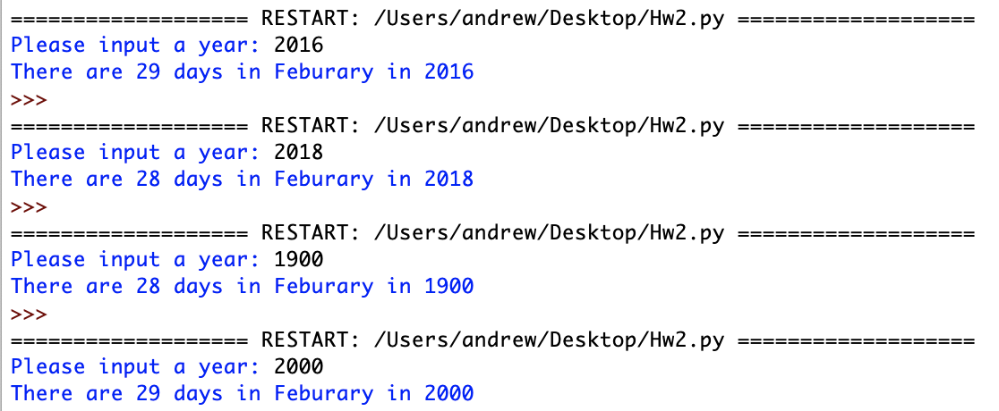

1. **Code**

################

# Author: Andrew Wang

# Date: 9/19/2019

# This program allows the user to input the quantity of boxes and the program will determine

# how much discount is applied and the total price.

#################

#user inputs amount of quantity

quantity = float(input('Please input the quantity of amount package bought: '))

#price of the package

price = 99

#if statement to determine if the quantity is <0

if quantity <= 0:

print('Invalid Input!')

else:

#if statement to determine the amount of quantity and apply the necessary discount

if quantity >= 10 and quantity <= 19:

print('10% discount applied')

discount = 0.9

elif quantity >= 20 and quantity <= 49:

print('25% discount applied')

discount = 0.75

elif quantity >= 50 and quantity <= 99:

print('35% discount applied')

discount = 0.65

elif quantity >= 100:

print('45% discount applied')

discount = 0.55

else:

print('No discount applied')

discount = 1

#calculates final price with discount applied

total_amt = price * quantity * discount

#prints amount of package and final price

print('The final price for purchasing '+str(int(quantity))+ ' packages is ${:,.2f}' .format(total_amt))

1. **Code:**

################

# Author: Andrew Wang

# Date: 9/19/2019

# This program allows the user to input a pocket number between 0 and 36 and

# and the program will determine the color of the pocket number

#################

#users inputs pocket number

pocket_num = float(input('Input a pocket number between 0 and 36: '))

#if statement that determines if pocket number is < 0 or > 36

if pocket_num < 0 or pocket_num > 36:

print('Invalid Input!')

else:

#if statement that determines the color of the pocket number

if pocket_num == 0:

print('The pocket %.0f is green' %pocket_num)

elif pocket_num >= 1 and pocket_num <= 10:

if (pocket_num % 2 == 0):

print('The pocket %.0f is black' %pocket_num)

else:

print('The pocket %.0f is red' %pocket_num)

elif pocket_num >= 11 and pocket_num <= 18:

if (pocket_num % 2 == 0):

print('The pocket %.0f is red' %pocket_num)

else:

print('The pocket %.0f is black' %pocket_num)

elif pocket_num >= 19 and pocket_num <= 28:

if (pocket_num % 2 == 0):

print('The pocket %.0f is black' %pocket_num)

else:

print('The pocket %.0f is red' %pocket_num)

elif pocket_num >= 29 and pocket_num <= 36:

if (pocket_num % 2 == 0):

print('The pocket %.0f is red' %pocket_num)

else:

print('The pocket %.0f is black' %pocket_num)

**Output:**

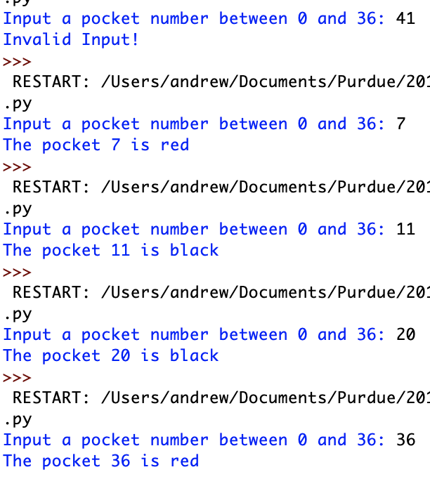

################

# Author: Andrew Wang

# Date: 9/19/2019

# This program allows the user to input total number of seconds and the program

# will convert total amount of time into days, hours, minutes, and seconds

#################

#user input total amount of seconds

seconds = float(input('Please enter a number of seconds: '))

#60 seconds in a minute

minutes = 60

#if statement to determine the total number of seconds and calculate days, hours, minutes, and seconds accordingly

if seconds < 60:

print('The number of seconds is less than one minute')

elif seconds >= 60 and seconds < 3600:

minute_calc = seconds // minutes

second_calc = seconds % minutes

print('%.0f seconds equal to: %.0f full minute(s) and %.0f second(s).' % (seconds, minute_calc, second_calc))

elif seconds >= 3600 and seconds < 86400:

hour_calc = seconds // (minutes * minutes)

minute_calc = seconds % (minutes * minutes) // minutes

second_calc = seconds % minutes

print('%.0f seconds equal to: %.0f full hour(s), %.0f full minute(s) and %.0f second(s).' % (seconds, hour_calc, minute_calc, second_calc))

elif seconds >= 86400:

day_calc = seconds // (minutes * minutes * 24)

hour_calc = seconds % (minutes * minutes * 24) // (minutes * minutes)

minute_calc = seconds % (minutes * minutes * 24) % (minutes * minutes) // minutes

second_calc = seconds % minutes

print('%.0f seconds equal to: %.0f full day(s), %.0f full hour(s), %.0f full minute(s) and %.0f second(s).' % (seconds, day_calc, hour_calc, minute_calc, second_calc))

**Output:  
**

################

# Author: Andrew Wang

# Date: 9/19/2019

# This program allows the user to input velocity, diameter of the pipe, and temperature which the program

# will use it to calculate Reynolds Number which is used in fluid mechanics.

#################

#user input velocity

velocity = float(input('Please input velocity: '))

#user input diameter of the pipe

diameter = float(input('Please input diameter of the pipe: '))

#user input temperature

temperature = float(input('Please input tempeature (5°C, 10°C ,15°C only): '))

#if statement which calculates Renyolds Number according to different temperature.

if temperature == 5:

kin_visc = 1.49e-6

Re_num = (velocity * diameter) / kin_visc

print('The Reynolds number for a flow at a speed of '+str(velocity)+ ' m/s in a pipe with '+str(diameter)+' m diameter @ '+str(temperature)+'°C is {:.2e}' .format(Re_num))

elif temperature == 10:

kin_visc = 1.31e-6

Re_num = (velocity * diameter) / kin_visc

print('The Reynolds number for a flow at a speed of '+str(velocity)+ ' m/s in a pipe with '+str(diameter)+' m diameter @ '+str(temperature)+'°C is {:.2e}' .format(Re_num))

elif temperature == 15:

kin_visc = 1.15e-6

Re_num = (velocity * diameter) / kin_visc

print('The Reynolds number for a flow at a speed of '+str(velocity)+ ' m/s in a pipe with '+str(diameter)+' m diameter @ '+str(temperature)+'°C is {:.2e}' .format(Re_num))

**Output:**

